**<<FPTIME SHOP>>**

**Software Requirement Specification**

– HCM, July 2023 –

# I. Overview

## 1. Introduction

My project is about a website that sells watches. Includes features such as purchase, product update, registration, login.

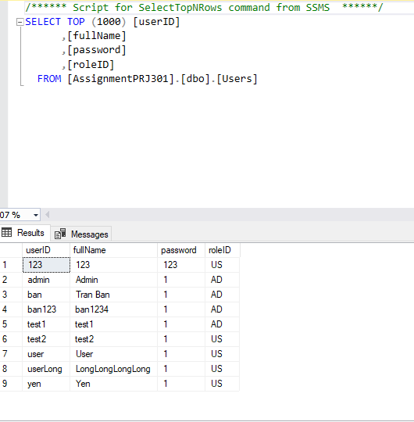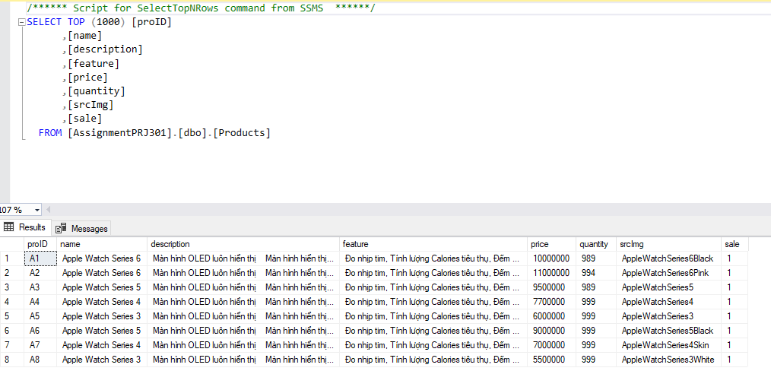

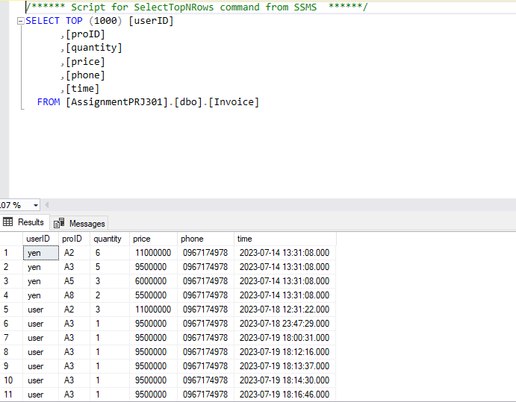

## 2. System Functions

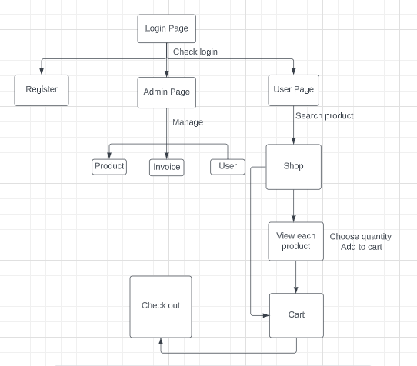

***b.1 User Wed Application***

|  |  |  |  |
| --- | --- | --- | --- |
| **#** | **Feature** | **Screen** | **Description** |
| 1 | Login account | Login page | Contains text box to input username and password, login button, register link. |
| 2 | Register account | Register page | Contains text box to input user information, register button |
| 4 | Get product | Shop page | Contains input text box to enter and search button |
| 5 | Get product detail | ViewProduct page | Contains input number box to enter and addtocart button |
| 6 | View cart | Cart page | Contain an button to checkout |
| 7 | Check out | Check out page | Contains input number box to enter phone number and checkout button |

# II. Functional Requirements

## 1. Login

Function description: The system allows users to use their username and password to log in to the system as customer

Screen layout:

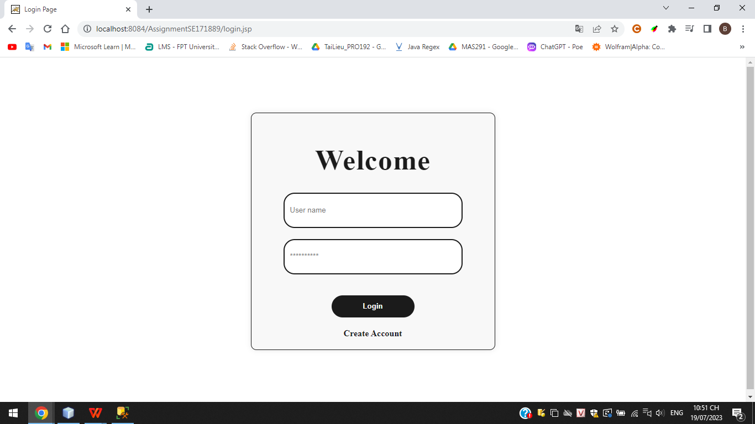

## 2. Register

Function trigger: after clicking register button

Function description: The system allows users to register for an account

Screen layout:

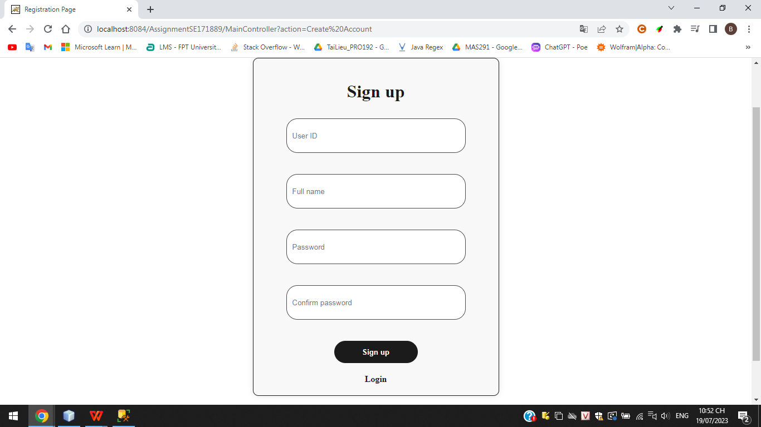

## 3. Show Shopping Page

Function trigger: after the clicking “Home” link or “Product” link

Function description: the system shows the product to user

Screen layout:

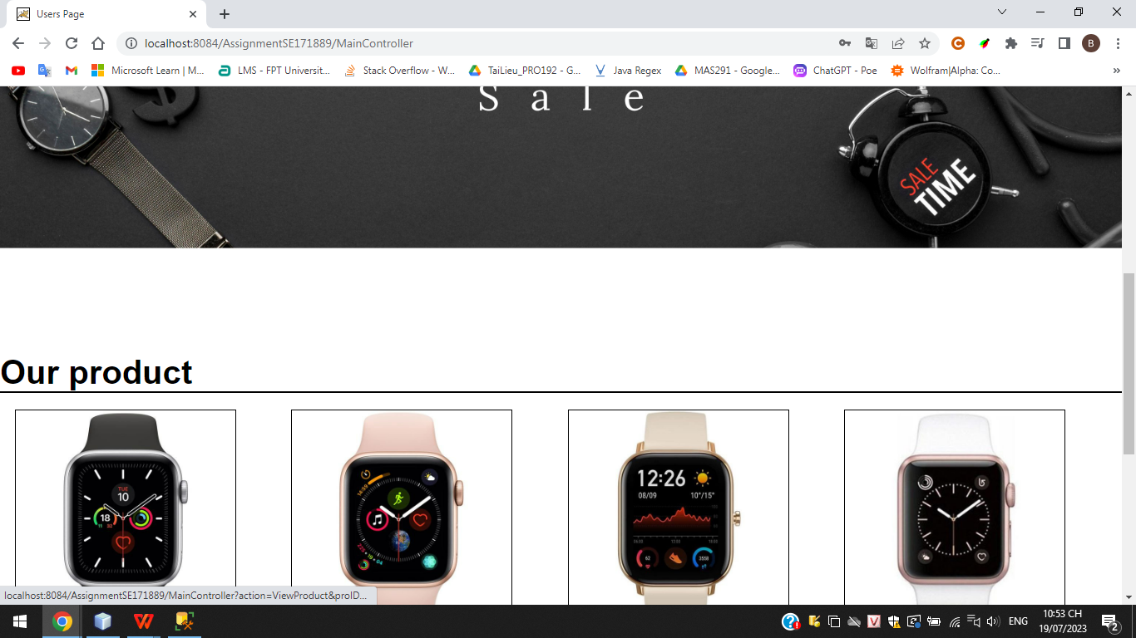

## 4. Search Product by name

Function trigger: after input name of product clicking search button

Function description: Display watch according to user’s search request

Screen Layout:

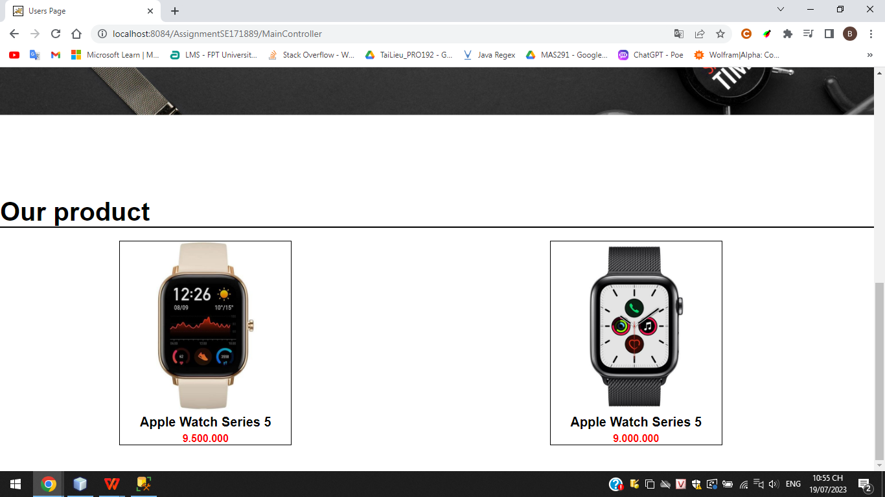

## 6. View Product detail

Screen layout:

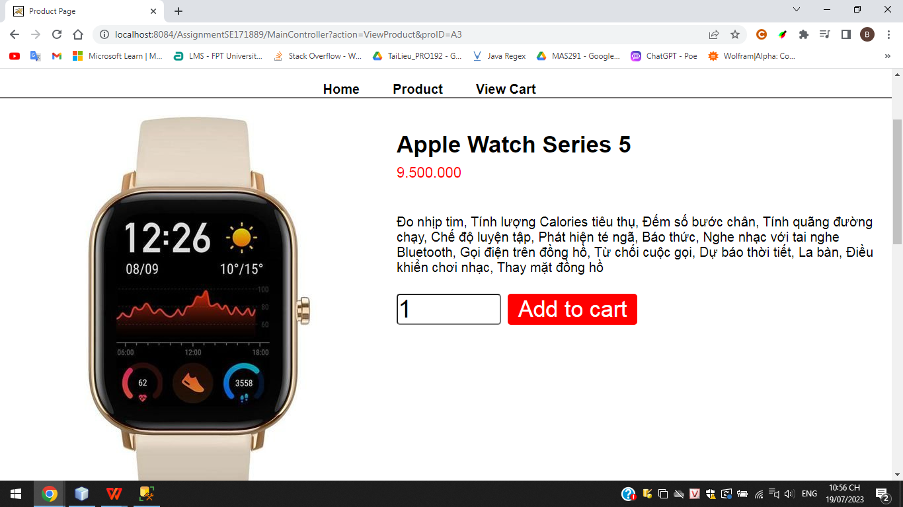

## 7. View cart

Function trigger: after choosing link View cart in header

Screen layout:

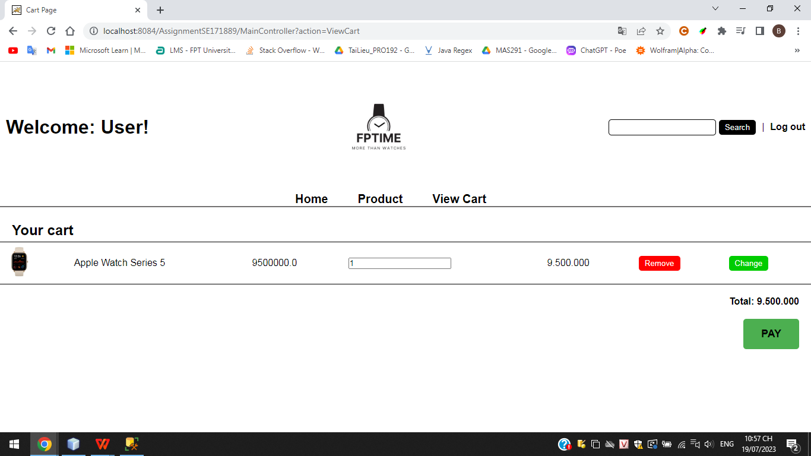

## 8. PAY

Function trigger: after choosing button PAY in Cart page

Function description: display an form to input phone number of consignee

Screen layout:

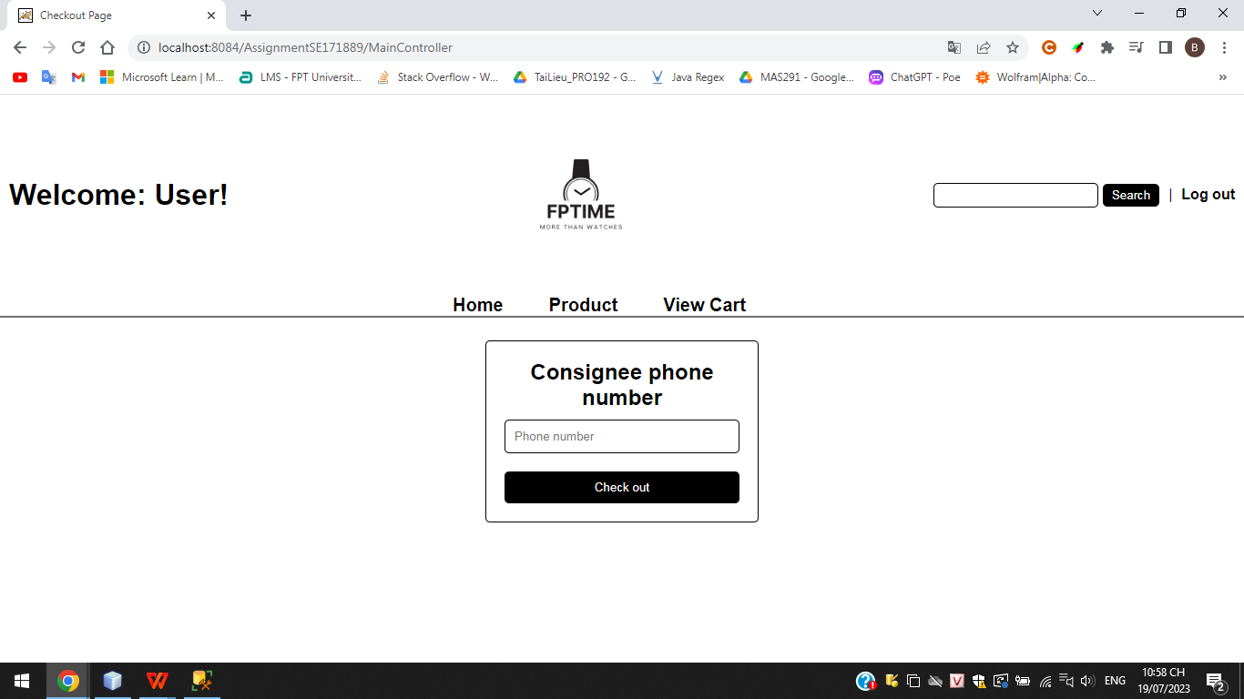

## 9 Notice of successful order

Function trigger: after clicking Check out

Function description: a success message is displayed on the screen

Screen layout:

